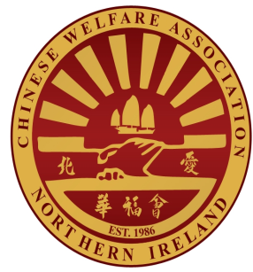

Monitoring Form
Job Ref _____/_______
This will be separated from your application upon receipt. Please tick the relevant boxes and return in the envelope provided. This information is used for monitoring of equality information only.

- Gender
What is your Sex?
Male
Female
Transgendered
I do not wish to answer
Date of Birth __________________________________________________________

- Sexual Orientation
I am Heterosexual
I am Gay or Lesbian (Homosexual)
I am Bisexual
Other (Specify) ________________________________________________________
I do not wish to answer
- Marital Status
Single Married
Separated/Divorced Widowed

- Community Background

I am a member of the Protestant Community

I am a member of the Roman Catholic Community

I am a member of neither the Protestant nor Roman
Catholic Community

- Religious Belief

Do you have a religious belief?

YES

NO
If yes are you:

Roman Catholic Presbyterian
Church Of Ireland Methodist
Baptist Muslim
Hindu Jewish
Buddhist Sikh
Baha’i

Other (Please Specify _______________________________________

- Those With and Without Dependents

Do you look after, or give any help or support to family members, friends, neighbours or dependents because of a long term physical or mental health problem or an issue related to old age?

Yes No

Dependents as regards young people/children?

Yes No

- Disability

The definition of a disability in the Disability Discrimination Act 1995 is: ‘A physical
or mental impairment which has a substantial and long-term adverse effect on a
person’s ability to carry out normal day-to-day activities’.

Do you meet (or have you, in the past, met) this definition? Yes No

IF YES, please tick below the heading which describes it best.

Mobility
Vision
Hearing
Speech
Dexterity / Co-Ordination
Mental
Learning
Other (Please specify) ………………………………………………………………

- Ethnic Origin

White Chinese Irish Traveller Indian

Bangladeshi Black African Black Caribbean

Black Other (Please Specify) ………………………………………………..………………

Mixed Ethnic Group (Please Specify) ………………………………………………..………………

Other (Please Specify) ………………………………………………..…………………………………….
Thank you for taking the time to complete this form, please return along with your completed application form. All Information provided will be held by Chinese Welfare Association in the strictest confidence and is for monitoring purposes only.

Funded by the Shared History Fund which The National Lottery Heritage Fund is distributing on behalf of the Northern Ireland Office

Chinese Welfare Association are an Equal Opportunities Employer.

